NEW MAGNETIC AND AGE GRIDS FOR THE NORTH ATLANTIC
Luis, J. F.⁽¹⁾, Miranda, J. M.⁽²⁾
- University of Algarve, IDL, Campus de Gambelas, 8000 Faro, Portugal
- Instituto Português do Mar e da Atmosfera, Rua C do Aeroporto de Lisboa, 1749 077 Portugal

Abstract
A new compilation of magnetic data for the North Atlantic area between 10N and 90N is presented here with a nominal horizontal resolution of 1’, upgrading the previous compilations for the same area. Magnetic data are corrected with CM4 model, extended to the whole period of the surveys, and all data are referred to the mean sea level to preserve original information, maximizing its usefulness for marine geophysical interpretation. A revision is made for the main magnetic chrons, based on the use of gridded data, continuous reduction to the pole and correlation, allowing the computation of an improved set of Euler poles for the Africa-North America plate pair and the analysis of the likelihood of previous determinations. As a subsidiary outcome, the time variation of the Mid-Atlantic spreading rate is computed and analyzed and a new age grid for the same area is made available. It is shown that … Finally we present what we consider to be the set of finite Euler rotations that best fit magnetic data, interpolated every 5 Myr. Neugebauer

1. Introduction
Magnetic anomaly maps when properly prepared are important tools for the study of the subsurface structure of the Earth and have wide use in exploration and research. In marine areas they are particularly useful because they provide invaluable information concerning the kinematic of the lithosphere, because it is possible to correlate changes of the oceanic crust magnetization with time. The collection of magnetic data is an easy and inexpensive task; however, the amount of new (and more accurate) marine magnetic data is not progressing significantly, while satellite magnetic sensors and modelling (e.g. Maus et al., 2009) are often used to complete data gaps and provide a continuous description of the magnetic anomalies across the ocean basins. These descriptions of the anomalous magnetic field are important for global studies but in all cases where a refined analysis of the geological history is needed, there is a need to base interpretations on real measurements and on processing that is not related with an understandable physical process. The compilation of a World Digital Magnetic Anomaly Map is underway (e.g. Quesnel et al., 2009); in this framework, detailed regional compilations are useful because they provide a complementary view, usually centered on the geological processes under study.
The magnetic compilation for the north Atlantic presented several years ago (Luis and Miranda, 2008) was made to support the research on the geodynamic evolution of the Azores triple junction. It covered the area between 35º N and 47º N and up to anomaly C33r, and was based on the collation of an updated set of marine magnetic profiles, the use of CM4 model whenever it falls inside the model validity period (up to 2002.7) and its extension beyond that period using the IGRF model to derive the secular variation and a daily variation computed with the CM4 model updated for the atmospheric coefficients (Sabaka et al., 2004). In this work we present an upgrade of that compilation, covering now the three megaplates Eurasia, Africa and North America, and we use that basic dataset to pick main magnetic chrons for the C-series and the M-series, north and south of the Azores-Gibraltar Fracture Zone. <deveriamos incluir porco-espinho e muro-de-pedra ou não?>
The availability of a homogeneous collection of magnetic chrons gives the opportunity to re-compute the Euler poles, for the whole period of the opening of the Central and North Atlantic. This is done exclusively using the magnetic grid, with the advantage that regional heterogeneities are easily understood and incorporated in the kinematic description. Thus, previous results for the Eurasia-North America plate pair up to chron C33r (Luis and Miranda, 2008) and for the Nubia-North America plate pair up to chron C6 (Miranda and Luis, submitted) are extended. A first outcome of the collection of Euler poles is the possibility to study the time variation of the spreading velocity in the Mid Atlantic ridge since Mesozoic times, with plate scale significance. A second outcome is the computation of a new age grid for the North-Atlantic with 30” resolution, deduced from independently picked chrons in the three megaplates to be used in geodynamic studies. A third outcome is a re-evaliation of previous determinations of Euler rotations, and the computation of finite rotations interpolated every 5 Myr, to be used in reconstitutions of the past locations of the Eurasia, Nubia, Iberia and North-America.

2. Magnetic Data Processing
The magnetic compilation presented here is an extension of the Luis and Miranda (2008) and Miranda and Luis (submitted) work. New data were added from inserir. Data were gridded using a minimum curvature algorithm with a final spacing of 1’.
In this study, all marine data of the GEODAS DVD Version 5.0.10 plus on line inquires of the NGDC database for more recent adding’s were considered. Besides these, the IFREMER SYSMER database was also consulted to find data that was not contributed to NGDC. Thanks to a most kind investigation of personal archives by Walter Roest it was possible to recover the so called “Collete collection”. Several other profiles come from cruises around the Iberian Peninsula in which the authors were in way collaborators but that had not been submitted to NGDC. We were also able to have access to Russian cruises kindly provided by S. Mercuriev. A final large package of data comes from the Portuguese program for the continental shelf extension (EPEPC). A map with the data source proveniences is displayed in Fig 1. Overall these data collection span over a long time period, specifically from a few older surveys from the 50’s to last ones in 2012. However, the time distribution is rather heterogeneous with a peak in the early 70’s and a significant decrease hereafter. The most notably exception is the Portuguese dataset but this one has a relatively limited area coverage. The age of the overall ensemble reflects visibly on the Crossover analysis. The crossover differences at the point of intersection depend on several factors, namely: the secular variations of the geomagnetic field, the external field contributions (the daily variation) and the positional (ship navigation) errors. To assess the global quality of the dataset a Crossover analysis [Wessel and Watts, 1988] is carried on here.
The removal of the main field and its temporal variations from the total field data was made with the use of CM4 (Comprehensive Model 4, Sabaka et al., 2004) which validity goes from 1960 up to July 2002. Some magnetic profiles in this compilation were made after
Marine magnetic anomalies are mainly a consequence of lateral changes in remanent magnetization, particularly magnetic reversals, and topography. Due to the non collinearity between the present main field and the preserved remanent magnetization,and their non-verticality, there is a “skewness” effect, that displaces the mid-points of magnetic stripes breaks the symmetry. This effect can be easily removed when the “reduction to the pole” is applied to the total field anomalies, taking into account the spatial variations of the both the remanance and the main field vectors, as long as one can infer the direction of the remanant magnetization. The approach done here considers that the original NRM is the main mechanism by which oceanic basalts acquire magnetization, at the ridge, and that it is stable over the whole opening of the Atlantic. Then, its direction in every point can be deduced from the Euler poles with respect to North America, and the APWP for that plate (see Luis and Miranda, 2008 for details).

3. Magnetic Chrons and Euler poles for the North Atlantic
Anomaly picking was based on the magnetic grid from the correlation between synthetic profiles interpolated from the reduced-to-the-pole grid, and 2D direct modeling built upon the geomagnetic polarity timescale of Cande and Kent (1995) assuming that both remanent and induced magnetizations are vertical, and taking into consideration the topography of the seafloor. For each chron specified in table I a reference age was chosen (see table I), usually corresponding to the maximum of the reduced-to-the-pole anomaly; this means that in most situations we are not choosing the same reference age of other works, because we are not dealing with magnetic profiles but with magnetic grids. In most cases the automatic correlation is sufficiently good to allow automatic “transfer” of the reference epoch of each chron to the magnetic map. The line that joins contiguous picks is the magnetic chron and the direct comparison between this line and the magnetic grid gives immediately a synoptic evaluation of its likelihood.
For the period of interest we considered that chrons C2, C2a, C3, C3a, C4, C4a, C5, C6, etc… can be reliably interpreted from the gridded magnetic data.
> análise dos polos existentes e discussão da sua validade
Greiner and Neugebauer (2013) provided a compilation of Euler rotations for the Central and North Atlantic to form what is considered as a “consistent model”, where the motion of the plates is described by “drift lines”. One of their goals is to clarify the positions of Africa, Iberia and Eurasia to support the reconstitution of the evolution of the western Tethys. They base their work on previously published “picks” and they seek internal consistency of the kinematic model and not a connection to the primary information: magnetic anomalies and geology (Frisch and Dawes, 2013). In table II we summarize finite rotation parameters previously published, correcting them to match the reference ages chosen in this study, to allow proper comparison.
> interpolação de 5Myr em 5 Myr

4. North Atlantic Age Grid and Changes in Spreading Velocity
The conclusions presented here are derived only from magnetic and topographical data. This means that no geological a priori is introduced in the interpretations.
> método para atribuição de idades
> variação da velocidade de spreading ao longo de 4 flow lines
> variação da spreading asymetry

5. Discussion and Conclusions
> filosofia de barbeiro sobre a segmentação
> filosofia de barbeiro sobre os limites da rigidez e integridade das placas Africana, Euroasiática Ibérica e Americana durante a abertura do Atlântico
> filosofia de barbeiro sobre a hipótese quase-estática

Acknowlegements
This work is a contribution from MAREKH FCT project and PEST … The original magnetic map, the reduced-to-the-pole version, the age grid and the magnetic chrons can be obtained from the authors.

References
Cande, S.C. and D.V. Kent (1995). Revised calibration of the geomagnetic polarity timescale for the late Cretaceous and Cenozoic: Table of ages for Cande and Kent GPTS J. Geophys. Res., 100, 6093-6095.
Frisch, T., & Dawes, P. R. (2013). The rotations opening the Central and Northern Atlantic Ocean: compilation, drift lines, and flow lines (Int J Earth Sci 102: 1357–1376). International Journal of Earth Sciences, 1-3.
Greiner, B., & Neugebauer, J. (2013). The rotations opening the Central and Northern Atlantic Ocean: compilation, drift lines, and flow lines. International Journal of Earth Sciences, 102(5), 1357-1376.
Luis, J.F. and J.M. Miranda (2008). Reevaluation of magnetic chrons in the North Atlantic between 35⁰N and 47⁰N: Implications for the formation of the Azores Triple Junction and associated plateau, Journal of Geophysical Research, 113, B10105, 12p.
Maus, S., Barckhausen, U., Berkenbosch, H., Bournas, N., Brozena, J., Childers, V., ... & Caratori Tontini, F. (2009). EMAG2: A 2–arc min resolution Earth Magnetic Anomaly Grid compiled from satellite, airborne, and marine magnetic measurements. Geochemistry, Geophysics, Geosystems, 10(8).
Miranda, J. M., Luis, J. F., Lourenço, N., & Santos, F. M. (2005). Identification of the magnetization low of the Lucky Strike hydrothermal vent using surface magnetic data. Journal of Geophysical Research: Solid Earth (1978–2012), 110(B4).
Quesnel, Y., Catalan, M., & Ishihara, T. (2009). A new global marine magnetic anomaly data set. Journal of Geophysical Research: Solid Earth (1978–2012), 114 (B4).
Sabaka, T. J., N. Olsen, and M. E. Purucker (2004), Extending comprehensive models of the Earth’s magnetic field with Ørsted and CHAMP data, Geophys. J. Int., 159, 521 - 547, doi:10.1111/j.1365-246X.2004.02421.x.

FIGURE CAPTIONS
Figure 1: Marine profiles merged in the present compilation
Figure 2: Histogram of cross-over differences using (A) IGRF only (B) using CM4 extended model. The standard deviation decreases significantly with the use of CM4.
Figure 3: Magnetic anomalies continuously reduced to the pole. Projection equidistant, with reference parallels 30ºN e 60ºN. Land areas are displayed in gray. White out oceanic areas show regions with no magnetic data.
Figure 4: Time variation of the spreading velocity in the Mid Atlantic Ridge along four flow-lines passing to (A) 60N, (B) 41N, (C) 35N, (D) 25N, where the latitudes correspond to the present day MAR.
Figure 5: North Atlantic 30” age-grid
Figure 1: Marine profiles merged in the present compilation

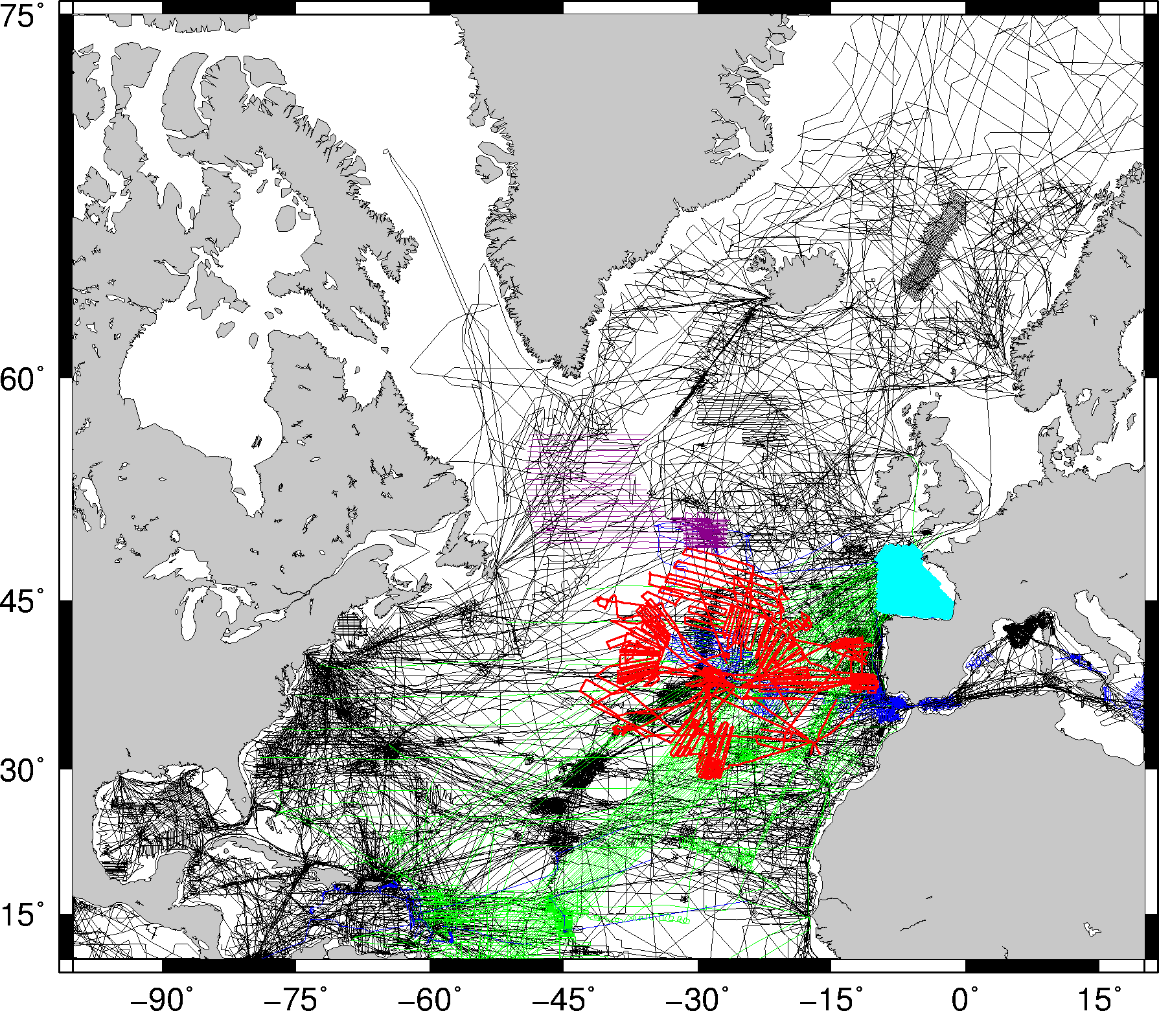
Figure 2: Histogram of cross-over differences using (A) IGRF only (B) using CM4 extended model. The standard deviation decreases significantly with the use of CM4.

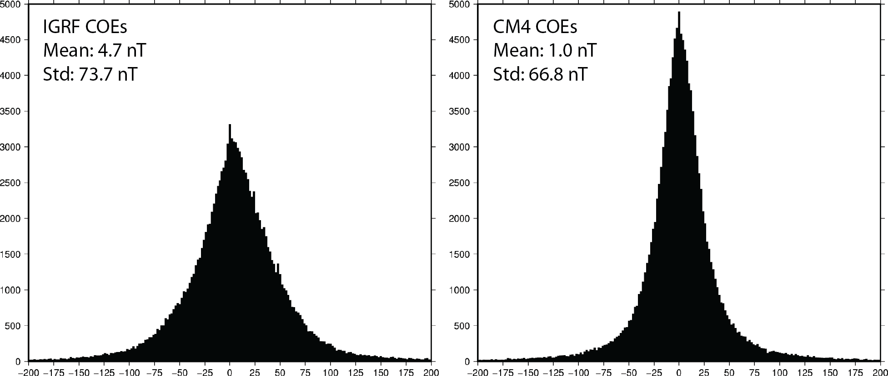
Figure 3: Magnetic anomalies continuously reduced to the pole. Projection equidistant, with reference parallels 30ºN e 60ºN. Land areas are displayed in gray. White out oceanic areas show regions with no magnetic data.
Figure 4: Main magnetic chrons for the Atlantic
Figure 5: Time variation of the spreading velocity in the Mid Atlantic Ridge along four flow-lines passing to (A) 60N, (B) 41N, (C) 35N, (D)25N, where the latitudes correspond to the present day MAR.
Figure 6: North Atlantic 30” age-grid
Table I: Eulerian finite best fit rotations for the Nubia/North American and Eurasia/North America plate pairs. Eurasia/Nubia finite rotation parameters are computed from the previous ones. Parameters up to C6 are from Miranda and Luis (submitted).
Chron | Age | Nubia - North America |  |  |  | Eurasia - North America |  |  |  | Eurasia - Nubia
Chron | Age | Lon | Lat | Ang | Res | Lon | Lat | Ang | Res | Lon | Lat | Ang
C2 | 1.82 | 41.1 | 79.2 | -0.42 | 2.03 | 143.9 | 44.9 | -0.39 | 1.15 | -21.25 | 24.30 | 0.3331
C2a | 3.06 | 41.8 | 78.0 | -0.71 | 1.65 | 140.9 | 49.8 | -0.63 | 1.86 | -20.81 | 25.20 | 0.4998
C3 | 4.72 | 34.7 | 78.6 | -1.12 | 2.05 | 138.0 | 61.0 | -1.03 | 2.36 | -20.10 | 18.35 | 0.6229
C3a | 6.20 | 41.0 | 79.0 | -1.46 | 1.82 | 139.4 | 55.6 | -1.29 | 1.97 | -20.21 | 24.17 | 0.8967
C4 | 7.74 | 50.4 | 79.4 | -1.79 | 1.73 | 140.4 | 56.5 | -1.62 | 1.74 | -18.53 | 23.05 | 1.0367
C4a | 8.88 | 49.3 | 79.3 | -2.14 | 1.54 | 139.2 | 59.7 | -1.94 | 1.77 | -17.67 | 21.87 | 1.1390
C5 | 10.30 | 55.0 | 79.6 | -2.56 | 2.67 | 139.0 | 60.3 | -2.32 | 2.45 | -17.12 | 22.62 | 1.2947
C6 | 19.60 | 43.1 | 80.5 | -5.35 | 4.30 | 139.5 | 62.0 | -4.58 | 3.94 | -16.65 | 26.66 | 2.7096
C13 |  |  |  |  |  |  |  |  |  | - | - | -
C18 |  |  |  |  |  |  |  |  |  | - | - | -
C20 |  |  |  |  |  |  |  |  |  | - | - | -
C21 |  |  |  |  |  |  |  |  |  | - | - | -
C22 |  |  |  |  |  |  |  |  |  | - | - | -
… |  |  |  |  |  |  |  |  |  | - | - | -

Table II: NU wrt NA
Chron | Age | Fixed Plate | Moving Plate | Longitude | Latitude | Angle | Residue | Reference
C2a | 3.06 | NA | NU | 41.8 | 78.0 | -0.71 | 1.65 | Miranda and Luis (submitted)
C2a | 3.06 | NA | NU
C5 | 10.30 | NA | NU | 55.0 | 79.6 | -2.56 | 2.67 | Miranda and Luis (submitted)
C5 | 9.78 | NA | NU | 22.82 | 80.98 | -2.478 |  | Muller et al. (1999)
C6 | 19.60 | NA | NU | 43.1 | 80.5 | -5.35 | 4.30 | Miranda and Luis (submitted)
C6 | 18.75 | NA | NU | 23.28 | 80.89 | -5.244 |  | Muller et al. (1999)
C8 | 25.30 | NA | NU | 28.56 | 79.34 | -7.042 |  | Muller et al. (1999)
C13 | 33.27 | NA | NU | 5.98 | 75.99 | -9.767 |  | Muller et al. (1999)
C13 |  | NA | NU
C18 | 38.03 | NA | NU | 0.19 | 74.54 | -11.918 |  | Muller et al. (1999)
C21 | 45.35 | NA | NU | -5.01 | 74.23 | -15.106 |  | Muller et al. (1999)
C24 | 52.65 | NA | NU |  |  |  |  | Muller et al. (1999)
C25 | 56.67 | NA | NU |  |  |  |  | Muller et al. (1999)
C30 | 65.86 | NA | NU |  |  |  |  | Muller et al. (1999)
C32 | 70.96 | NA | NU |  |  |  |  | Muller et al. (1999)
C33o | 79.54 | NA | NU |  |  |  |  | Muller et al. (1999)
C34 | 84.00 | NA | NU |  |  |  |  | Muller et al. (1999)
M0 | 124.61 | NA | NU |  |  |  |  | Roest et al. (1992)
M4 | 129.76 | NA | NU |  |  |  |  | Roest et al. (1992)
M11 | 135.69 | NA | NU |  |  |  |  | Roest et al. (1992)
M16 | 141.05 | NA | NU |  |  |  |  | Roest et al. (1992)
M21 | 147.77 | NA | NU |  |  |  |  | Roest et al. (1992)
M25 | 154.08 | NA | NU |  |  |  |  | Srivastava et al. (1990)
BSMA | 170.00 | NA | NU |  |  |  |  | Klitgord and Schouten (1986)
CT | 154.08 | NA | NU |  |  |  |  | Srivastava and Verohef (1992)

Table III: EU wrt NA
Chron | Age | Fixed Plate | Moving Plate | Longitude | Latitude | Angle | Residue | Reference
C2a | 3.06 | NA | EU | 140.9 | 49.8 | -0.63 | 1.86 | Miranda and Luis (submitted)
C2a | 3.06 | NA | EU
C5 | 10.30 | NA | EU | 139.0 | 60.3 | -2.32 | 2.45 | Miranda and Luis (submitted)
C5 | 9.78 | NA | EU | 132.47 | 68.06 | -2.54 |  | Lawver et al. (2002)
C6 | 19.60 | NA | EU | 139.5 | 62.0 | -4.58 | 3.94 | Miranda and Luis (submitted)
C6 | 18.75 | NA | EU | 128.76 | 69.77 | -4.93 |  | Lawver et al. (2002)
C8 | 25.30 | NA | EU |  |  |  |  | Muller et al. (1999)
C13 | 33.27 | NA | EU |  |  |  |  | Muller et al. (1999)
C13 |  | NA | EU
C18 | 38.03 | NA | EU |  |  |  |  | Muller et al. (1999)
C21 | 45.35 | NA | EU |  |  |  |  | Muller et al. (1999)
C24 | 52.65 | NA | EU |  |  |  |  | Muller et al. (1999)
C25 | 56.67 | NA | EU |  |  |  |  | Muller et al. (1999)
C30 | 65.86 | NA | EU |  |  |  |  | Muller et al. (1999)
C32 | 70.96 | NA | EU |  |  |  |  | Muller et al. (1999)
C33o | 79.54 | NA | EU |  |  |  |  | Muller et al. (1999)
C34 | 84.00 | NA | EU |  |  |  |  | Muller et al. (1999)
M0 | 124.61 | NA | EU |  |  |  |  | Roest et al. (1992)
M4 | 129.76 | NA | EU |  |  |  |  | Roest et al. (1992)
M11 | 135.69 | NA | EU |  |  |  |  | Roest et al. (1992)
M16 | 141.05 | NA | EU |  |  |  |  | Roest et al. (1992)
M21 | 147.77 | NA | EU |  |  |  |  | Roest et al. (1992)
M25 | 154.08 | NA | EU |  |  |  |  | Srivastava et al. (1990)
BSMA | 170.00 | NA | EU |  |  |  |  | Klitgord and Schouten (1986)
CT | 154.08 | NA | EU |  |  |  |  | Srivastava and Verohef (1992)

